Three Observations on the Relationship Between a City’s Latitude and its Weather

-Alex Young

1. Latitude seems to have a slightly negative relationship with a city’s maximum temperature.

When we first look at this chart, we may not see any discernable trends.

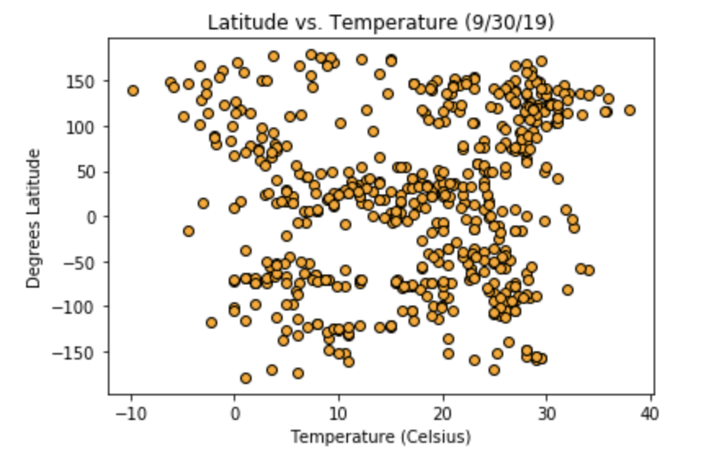

However, we should be more concerned with the absolute value of a city’s latitude, as that shows us its proximity to the equator. Cities closer to the equator (where latitude = 0), are closer to the sun and thus tend to be hotter on average. If we split the graph in half, we can see an ever so slightly negative relationship.

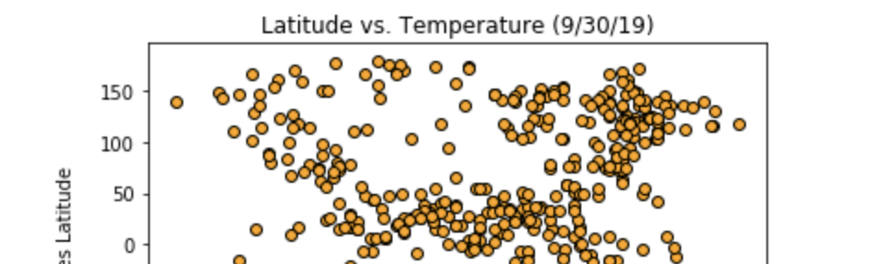

This relationship appeared a little more pronounced when I ran the same data graph the night before (9/29/19), so we’d have to take in more data to prove any statistical significance.

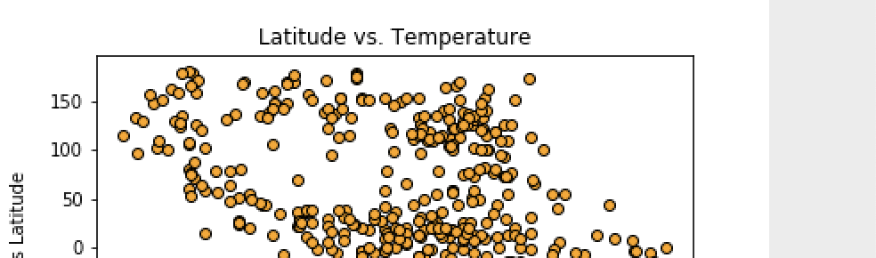

2. Latitude seems to have less of a discernible relationship with humidity, cloudiness, and wind speed.

I took the same cross-section charts for these factors and did not spot any definitive trends.

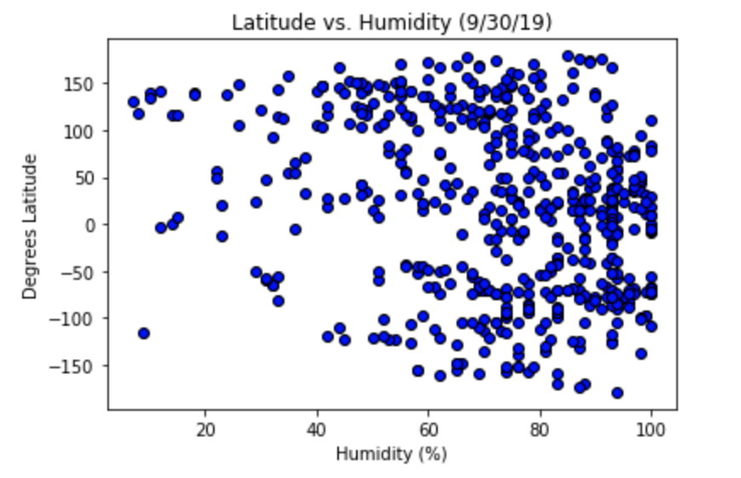

Latitude and humidity may have a slightly negative relationship, as evidenced by this top half of the cross-section below. However, we would have to run a significance test to see if it’s not just due to randomness. Humidity tends to be rather high irrespective of latitude.



With most of the cloudiness data spread perpendicular to latitude, there seems to be no relationship.

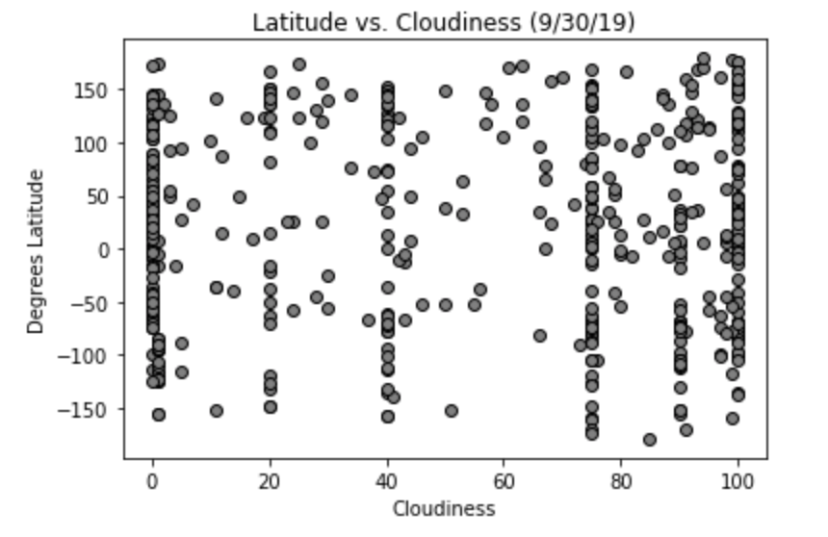

I was hoping to find more of a relationship between latitude and wind speed. By my understanding, wind is generated by the displacement of hot and cool air, which tends to happen near the coasts. Thus, I was wondering if there was any part of the map that was more susceptible to these changes in atmospheric pressure. There definitely is, but it may not be related to that place’s latitude.

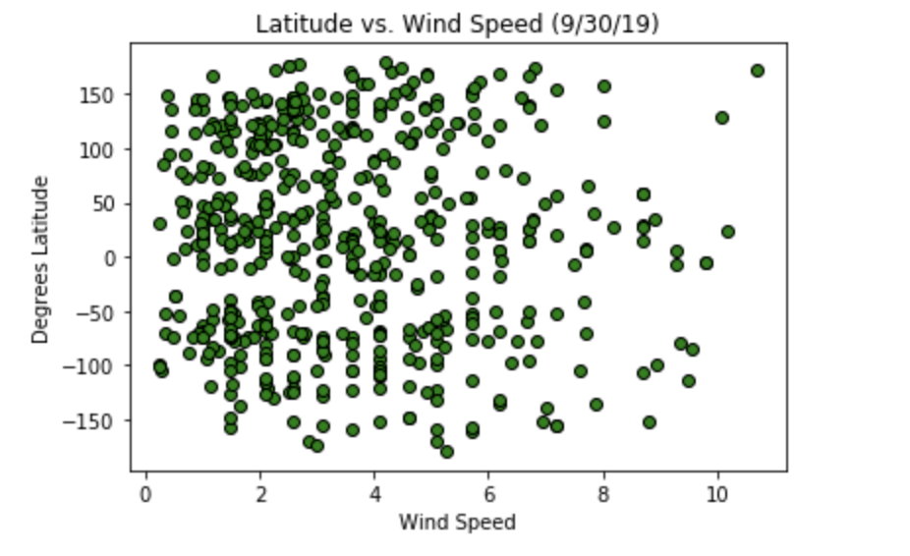

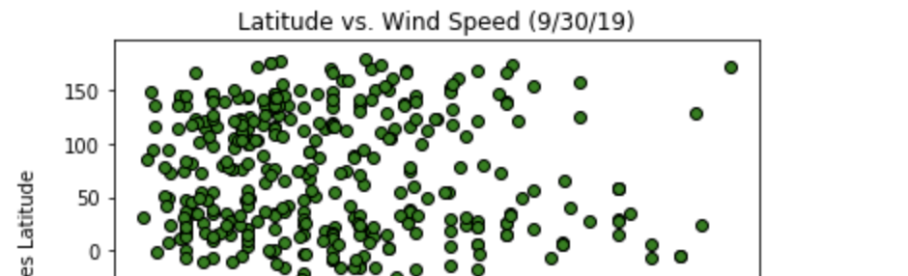

3. Lack of precision may make certain relationships hard to spot.

Looking back at the Latitude vs. Cloudiness graph, we can see that most cloudiness appears to be measured in roughly 20% intervals. We have data clustered at 0, 20%, 40%, and other milestone numbers along the x-axis. I wonder if having more precise data would help us better spot a positive or negative relationship.

Likewise, the windspeed of one city seems to be relatively close to that of another, with some set intervals of perhaps every .1 km/hr. Having more precise measurements may help with that.

As a side note, it would be interesting to see the effect of latitude on all of these factors, especially wind speed. In a lot of places, the wind tends to blow at night. Since roughly half of all latitudes are facing the nighttime at any given point, it’ll be interesting to see how they all compare.